Producing Dashboard Reports on the Simplybook Booking Platform
To support the Covid-19 vaccination delivery
Contents
1 Definition and Purpose 3
2 Dashboard Reports 3
2.1 Dashboard 3

- Definition and Purpose
This booklet sets out the operational processes for system administrators to produce dashboard reports. Dashboard provides a graphical representation of appointments at each of the calendars. This can be done to display daily, weekly, monthly, yearly or custom time frame.
Should you not be able to find the support you require within this document, please contact the jbs.enquiries@miaa.nhs.uk mailbox, where one of the team will be able to assist.
- Dashboard Reports
  - Dashboard
For users with Admin access and above
Open your Simplybook account from the admin interface (using a website link).
Select ‘Dashboard’ from the sidebar menu
Scroll to the bottom
You will now need to set the date parameters
Adjust the screen to make sure that the above view fits neatly on to a single page (you can do this by pressing Ctrl key on your keyboard and moving your mouse wheel up or down, or pressing Ctrl key on your keyboard and clicking +/-)
Make sure that the dashboard graphic page fits onto a single view:
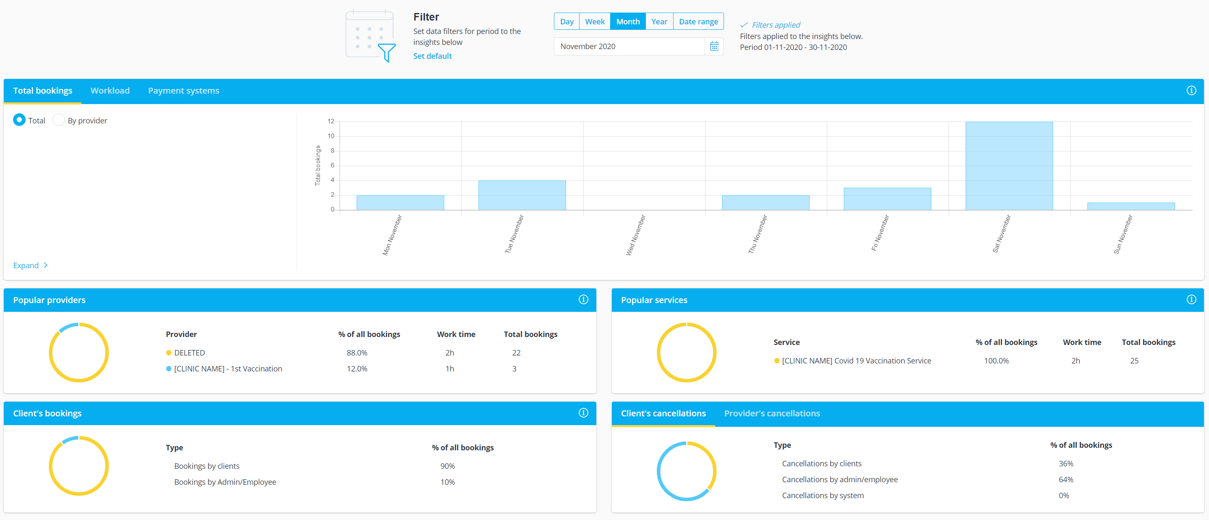

Open the snipping tool, or take a screenshot (or on your keyboard hold down Ctrl, Alt and click print screen)
Paste the snipped/ copied image dashboard into a word document (Ctrl V)
Enter a title to you Dashboard, for example: “[Clinic Name] Monthly Dashboard of Activity –covering DDMMYYYY – DDMMYYYY’.
Save your document.

